II. Speaking
Section A
Directions: Read aloud the following two sentences. For each sentence, you will have thirty seconds to prepare and fifteen seconds to read.
1. She crafted delicate jewelry with skillful hands, weaving stories into each unique piece.
2. On the crowded train, passengers were absorbed in their own worlds, some reading, others lost in thought, all sharing a journey through the heart of the busy city.

Section B
Directions: Read aloud the following passage. You will have one minute to prepare and thirty seconds to read.
Outdoor activities play a crucial role in overall well-being, offering both physical and mental health benefits. Engaging in activities like hiking, cycling, or even a simple walk in the park can significantly increase physical fitness. Being outdoors also exposes individuals to natural sunlight, which is vital for the production of something crucial for bone health and body defence. Additionally, outdoor activities provide a mental health boost. Nature’s calming effect can reduce stress, improve mood, and enhance focus and creativity. They also offer opportunities for social interaction and community engagement. In today’s fast-paced digital world, making time for outdoor activities is essential for maintaining a balanced and healthy lifestyle.

Section C
Directions: Ask two questions about each situation given below. At least one special question should be asked about each situation.

Questions 1~2: Your classmate, Xiao Li, suggests you join a study group for the upcoming exams. Ask him two questions about the study group.
参考答案
(1) How often does the study group meet?
(2) What subjects are primarily focused on?
(3) What is the usual format of the study group sessions?
(4) How are topics chosen and discussed?

Questions 3~4: You’re quite interested in the architecture. Ask an architect about it in an interview.
参考答案
(1) How do you think the architecture reflects people’s cultural values?
(2) When you design architecture, what factors do you always take into consideration?

Section D
Directions: You will have one minute to prepare and another minute to talk in at least five sentences about the following pictures. Begin your talk with the sentence given:

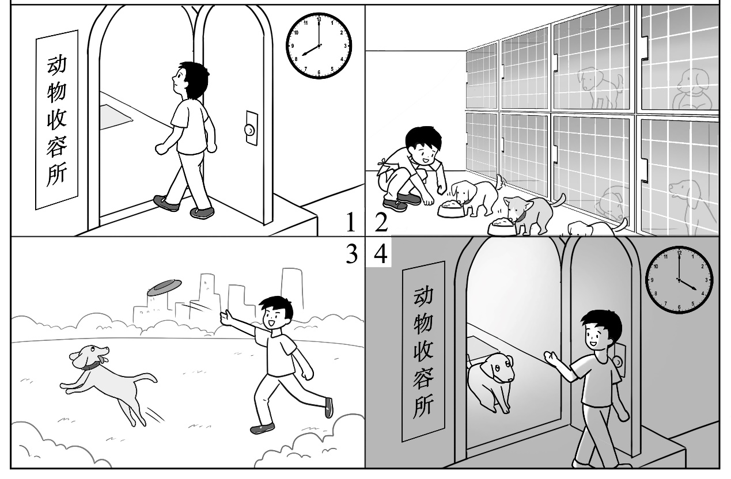
Xiao Ming spends his weekends volunteering at the local animal shelter.

III. Listening and Speaking
Section A
Directions: In Section A, you will hear four sentences. Make quick responses to the sentences you have heard.
1. What time will you be home after school today?
2. It’s your turn to give a presentation on behalf of your team. What is the topic of your presentation?
3. Can you help me with my homework later?
4. What are your goals for this term, either academically or personally?
参考答案
1. I’ll be home around 4:30 PM today.
2. Our presentation is about renewable energy sources.
3. Sure, happy to help with your homework later.
4. Academically, I aim to improve my math grades; personally, I want to start learning guitar.

Section B
Directions: In Section B, you will hear a short passage. The passage will be read twice. After you hear the passage, answer the first question with the information you hear and the second question in your own opinion with at least 3 sentences. For the first question, you will have 30 seconds to prepare and 30 seconds to talk. For the second question, you will have one minute to prepare and another minute to talk.

A good parent-child relationship lays a foundation for the child’s development and well-being. There are several things that parents can do.
First of all, create shared experiences. Parents and children can engage in activities that they both enjoy. It could be something as simple as cooking a meal together, going for a walk in the park, or playing a board game. These shared experiences create positive memories and strengthen the bond.
Then, show true respect. It’s about parents really listening to their children, understanding their thoughts and feelings, and guiding them without pressing. Imagine a space where a child feels completely heard and valued—that’s what we’re aiming for. It’s about building self-respect and confidence in our children.
Being consistent in parenting is also crucial. When parents are consistent, children learn that they can rely on what their parents say. For example, if a parent always keeps his promise to take the child to the park on Saturday if he cleans his room during the week, the child trusts that the parent will follow through. This trust provides a secure environment. Knowing what to expect in terms of rules, rewards, and punishments gives children a feeling of safety.
In conclusion, parents who can create shared experiences, respect their children and remain consistent the whole time can help build a good parent-child relationship.
Now listen again.
Questions
1. What can parents do to ensure a good parent-child relationship? List two of them.
参考答案
(1) They can create shared experiences. The shared activities can help children create positive memories and strengthen the bond.
(2) They can show true respect. This is about building self-respect and confidence in children.
(3) They can be consistent. This gives children a feeling of safety.

2. What do you think is the most important in communication with your parents? Why?

